ECAO3O5- SIGNALS AND SYSTEMS
NAME: S.GOKUL
REG NO: 192512373
Experiment No.: 8
Title: Laplace Transform, Inverse Transform, ROC and Stability
Objective (ii): Determination of Inverse Laplace Transform for Signal Reconstruction
AIM
To determine the inverse Laplace transform of a given frequency-domain representation and reconstruct the corresponding time-domain signal using MATLAB.
APPARATUS / SOFTWARE REQUIRED
1. Computer / Laboratory PC
2. MATLAB software
3. Symbolic Math Toolbox
THEORY
The inverse Laplace transform converts a function X(s) in the complex frequency domain back to the time-domain signal x(t). For a rational function X(s), it is found by partial-fraction expansion, and each term is replaced by its standard transform pair.
For X(s) = 1/[(s + 2)(s + 3)], the partial fractions are 1/(s + 2) − 1/(s + 3), so x(t) = e^(−2t) − e^(−3t) for t ≥ 0. Both poles lie in the left half of the s-plane, so the response decays to zero. In MATLAB the Symbolic Math Toolbox function ilaplace is used.
FORMULAE USED
X(s) = 1 / [(s + 2)(s + 3)]
Partial fractions: X(s) = 1/(s + 2) − 1/(s + 3)
x(t) = e^(−2t) − e^(−3t), t ≥ 0
ALGORITHM / PROCEDURE
- Start MATLAB and define the symbolic variables s and t.
- Define X(s) = 1/((s + 2)(s + 3)) symbolically.
- Apply ilaplace to obtain the time-domain signal x(t) and display it.
- Evaluate x(t) over 0 ≤ t ≤ 5 s with a step of 0.001 s.
- Plot the reconstructed time-domain signal with title, labels and grid.
- Compare the plotted response with the analytical expression.
INPUT PARAMETERS
S.No. | Input Parameter | Symbol / Setting | Value | Unit
1 | Laplace-domain signal | X(s) | 1/((s+2)(s+3)) | —
2 | Time range | t | 0 to 5 | s
3 | Time step | Δt | 0.001 | s
4 | Toolbox | — | Symbolic Math Toolbox | —

PROGRAM (MATLAB CODE)
clc; clear; close all;
%% 8(ii) Determination of Inverse Laplace Transform for Signal Reconstruction
figure;
% Inverse Laplace Transform
% Requires Symbolic Math Toolbox
syms s t
X = 1/((s+2)*(s+3));
x = ilaplace(X,s,t);
disp('Inverse Laplace Transform x(t) =');
pretty(x);
tt = 0:0.001:5;
xx = double(subs(x,t,tt));
plot(tt,xx,'LineWidth',1.2);
grid on;
xlabel('Time (s)');
ylabel('Amplitude');
title('Signal Reconstructed using Inverse Laplace Transform');
OUTPUT
Command Window:
Inverse Laplace Transform x(t) =
exp(-2 t) - exp(-3 t)

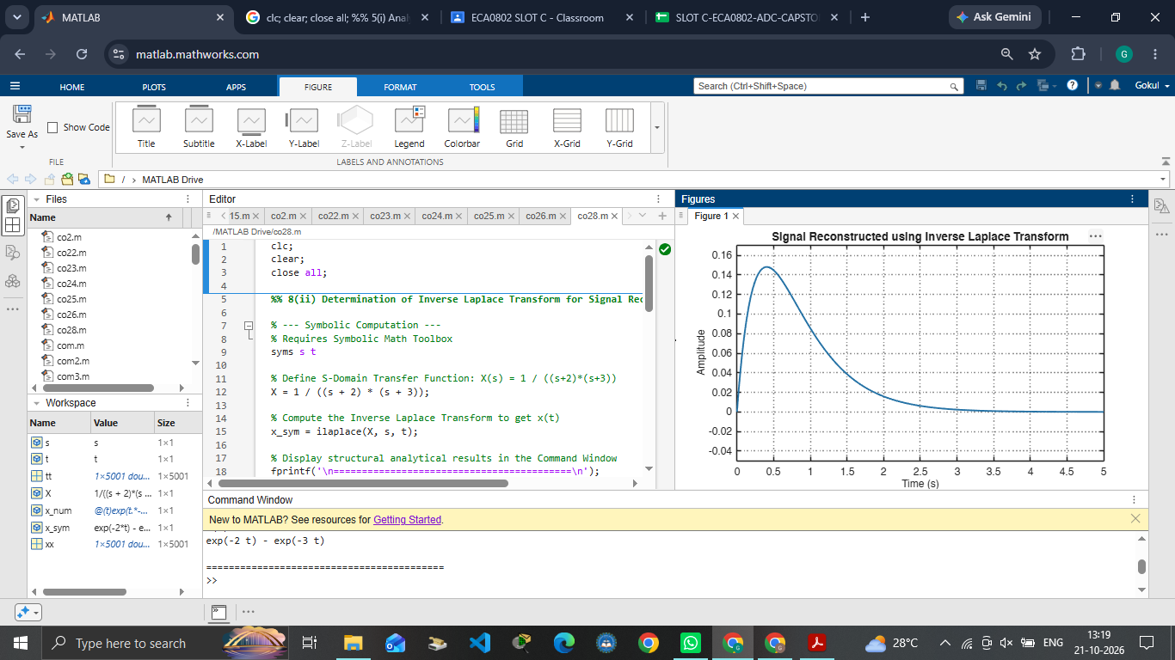
Fig. 8.1 Time-domain signal reconstructed using the inverse Laplace transform
OUTPUT PARAMETERS (THEORETICAL vs SIMULATED)
S.No. | Output Parameter | Theoretical Value | Simulated Value | % Deviation
1 | Inverse transform | e^(−2t) − e^(−3t) | exp(−2t) − exp(−3t) | Correct form
2 | Initial value x(0) | 0 | 0 | Correct
3 | Peak value | 0.148 at t = 0.405 s | ≈ 0.148 at t ≈ 0.4 s | Qualitative match
4 | Final value | Approaches 0 | ≈ 0 at t = 5 s | Qualitative match

RESULT
The inverse Laplace transform of X(s) = 1/[(s + 2)(s + 3)] was obtained as x(t) = e^(−2t) − e^(−3t). The reconstructed signal starts at 0, rises to a peak of about 0.148 near t = 0.4 s and then decays toward zero, which matches the analytical expression.

Objective (iii): To determine the Region of Convergence (ROC) of Laplace transforms and analyze its significance in characterizing continuous-time signals and systems.
AIM
To determine the Region of Convergence (ROC) of a Laplace transform and analyze its significance in characterizing continuous-time signals and systems using MATLAB.
APPARATUS / SOFTWARE REQUIRED
1. Computer / Laboratory PC
2. MATLAB software (with Signal Processing environment)
THEORY
The Region of Convergence (ROC) is the set of values of s for which the Laplace transform integral converges. The ROC is bounded by vertical lines through the poles in the s-plane, it cannot contain any pole, and the same X(s) can correspond to different time signals depending on the ROC.
For X(s) = 1/[(s + 2)(s + 4)] the poles are at s = −2 and s = −4. For a right-sided signal the ROC lies to the right of the rightmost pole, Re(s) > −2. For a left-sided signal it lies to the left of the leftmost pole, Re(s) < −4. For a two-sided signal it is the strip −4 < Re(s) < −2. A system is stable when the ROC includes the jω axis; here this happens only for the right-sided (causal) case.
FORMULAE USED
X(s) = 1 / [(s + 2)(s + 4)]; poles at s = −2 and s = −4
Right-sided ROC: Re(s) > −2
Left-sided ROC: Re(s) < −4
Two-sided ROC: −4 < Re(s) < −2
ALGORITHM / PROCEDURE
- Start MATLAB and define the pole locations p = [−2 −4].
- Plot the poles in the s-plane using ‘x’ markers.
- Mark the vertical lines through the poles using xline.
- State the candidate ROC for the right-sided, left-sided and two-sided cases using fprintf.
- Interpret the relationship between the poles and the ROC.
INPUT PARAMETERS
S.No. | Input Parameter | Symbol / Setting | Value | Unit
1 | Laplace transform | X(s) | 1/((s+2)(s+4)) | —
2 | Pole 1 | s₁ | −2 | —
3 | Pole 2 | s₂ | −4 | —
4 | Signal cases | — | Right / Left / Two-sided | —

PROGRAM (MATLAB CODE)
clc; clear; close all;
%% 8(iii) Analysis of Region of Convergence (ROC) and Its Significance in System Analysis
figure;
% ROC Analysis for a Rational Laplace Transform
% Requires Symbolic Math Toolbox
% X(s) = 1/((s+2)(s+4))
% Poles are at s = -2 and s = -4.
p = [-2 -4];
plot(real(p),imag(p),'rx','MarkerSize',10,'LineWidth',2);
hold on;
xline(-2,'--'); xline(-4,'--');
grid on;
xlabel('Real(s)'); ylabel('Imag(s)');
title('Poles and Candidate Regions of Convergence');
legend('Poles','Pole at -2','Pole at -4');
fprintf('Poles are at s = -2 and s = -4.\n');
fprintf('For a right-sided signal, ROC: Re(s) > -2.\n');
fprintf('For a left-sided signal, ROC: Re(s) < -4.\n');
fprintf('For a two-sided signal, ROC: -4 < Re(s) < -2.\n');
OUTPUT
Command Window:
Poles are at s = -2 and s = -4.
For a right-sided signal, ROC: Re(s) > -2.
For a left-sided signal, ROC: Re(s) < -4.
For a two-sided signal, ROC: -4 < Re(s) < -2.

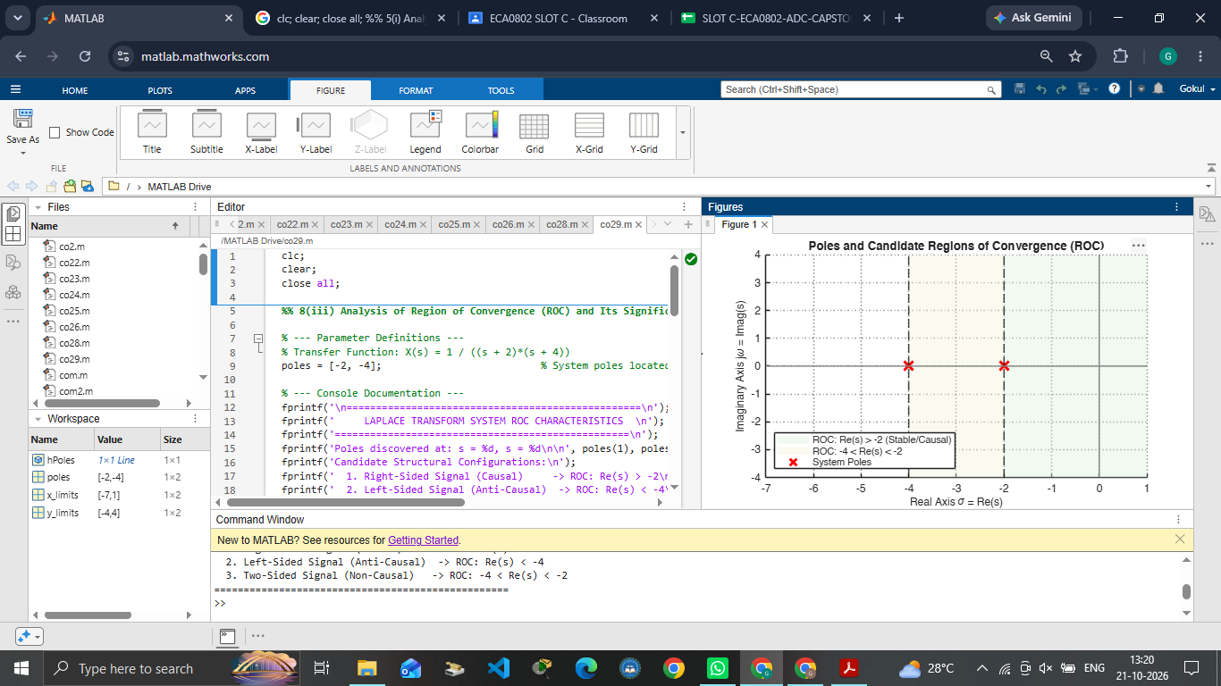
Fig. 8.2 Poles of X(s) and the vertical lines bounding the candidate ROCs
OUTPUT PARAMETERS (THEORETICAL vs SIMULATED)
S.No. | Output Parameter | Theoretical Value | Simulated Value | % Deviation
1 | Pole locations | −2 and −4 | −2 and −4 | Correct
2 | Right-sided ROC | Re(s) > −2 | Re(s) > −2 | Correct
3 | Left-sided ROC | Re(s) < −4 | Re(s) < −4 | Correct
4 | Two-sided ROC | −4 < Re(s) < −2 | −4 < Re(s) < −2 | Correct

RESULT
The poles of X(s) = 1/[(s + 2)(s + 4)] were found at s = −2 and s = −4. The ROC is Re(s) > −2 for a right-sided signal, Re(s) < −4 for a left-sided signal and −4 < Re(s) < −2 for a two-sided signal, and in each case the ROC does not contain any pole.

LABORATORY PERFORMANCE ASSESSMENT RUBRICS:

Objective | Assessment Criterion | Excellent – 4 | Good – 3 | Satisfactory – 2 | Needs Improvement – 1 | Weightage | Marks given | Marks obtained
(i) Determine the inverse Laplace transform of a given frequency-domain representation and reconstruct the corresponding time-domain signal. | Inverse Laplace Transform Evaluation | Correctly expands X(s) using partial fractions (distinct, repeated and complex poles) and applies the standard transform pairs and properties. Obtains the exact time-domain expression x(t), including the unit step u(t) and any shifts, with correct constants. | Applies partial fractions and transform pairs correctly, with minor errors in residues, constants or step-function terms. | Performs basic inverse transforms but has noticeable errors in partial fractions or transform pairs, and needs guidance. | Unable to determine the inverse Laplace transform. | 20 | 2
 | Time-Domain Reconstruction & MATLAB Implementation | Uses suitable MATLAB commands (residue, ilaplace, syms, impulse or step) with a proper time vector. Reconstructs and plots x(t) with titles, axis labels and grid, and verifies the numerical result against the analytical expression. | Reconstructs and plots the signal correctly, with minor errors in code, time range, parameters or labelling. | Generates a basic reconstruction with noticeable errors in code or plots, and needs assistance. | Unable to reconstruct the time-domain signal or produce meaningful plots. | 20 | 2
(ii) Determine the Region of Convergence (ROC) of Laplace transforms and analyze its significance in characterizing continuous-time signals and systems. | ROC Determination | Correctly determines the ROC for right-sided, left-sided, two-sided and finite-duration signals from the pole locations. States the ROC as a proper inequality on Re(s) and shows it on the s-plane with poles and zeros marked. | Determines the ROC correctly for most signals, with minor errors in the boundary, signal type or s-plane plot. | Determines the ROC for basic cases only, with noticeable errors, and needs guidance. | Unable to determine the ROC of the given Laplace transforms. | 20 | 2
 | ROC Significance for Signals and Systems | Clearly relates the ROC to the signal type, causality and BIBO stability (ROC contains the jω-axis), and shows that the same X(s) with different ROCs gives different time signals. Supports the reasoning with mathematical conditions and pole-zero evidence. | Relates the ROC to causality and stability correctly, with minor errors or limited justification. | Gives a basic explanation of the ROC's significance. Justification is incomplete and needs guidance. | Unable to explain the significance of the ROC. | 20 | 2
Interpret the Laplace-domain results and document the experiment. | Engineering Analysis, Interpretation & Record | Provides technically accurate interpretation of the results (pole locations, ROC and signal behaviour). Maintains a complete, well-organized record with code, outputs, plots and conclusions. | Maintains a proper record with generally accurate interpretation, with minor omissions. | Record and interpretation are basic and incomplete, with some technical inaccuracies. | Incomplete record, limited or incorrect interpretation of the results. | 20 | 2
 |  |  |  |  | Total | 100 | 10

